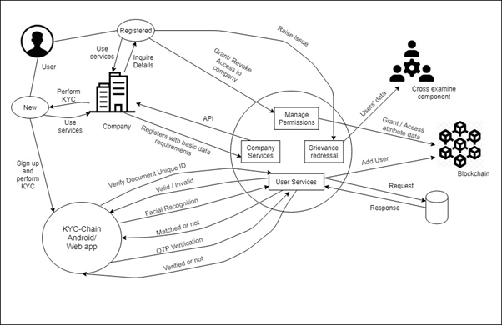

**Problem Statement**

Frequent cases of data leakage have brought into focus the security issues with different KYC programs. A consumer is expected to provide his personal identity for authentication by different agencies which are known as KYC but there is no restriction on how much data to be shared with the agencies needing the KYC. Consumers should have full control over where and how much data is being used by the third parties.

**Frequent data leaks, redundant KYC process, cost of manual KYC** are the major problems in today’s scenario. We have come with a solution where the user will have control over his/her personal data.

The user will have to do the KYC process only once. Verification is done using Aadhar or PAN + Electricity bill using facial recognition methods, and OTP. The users will take a picture of themselves on their mobile(if using app) or webcam. This photo will be checked with that of their Aadhar ID or PAN card. Aadhar and PAN+Electricity bill is used as a photo and address proof. The companies can verify that the user is authenticated or not. A new user (not authenticated) can signup and perform the KYC process through our Android app or web application.The user will receive a unique ID known as Uni-kyc. Similarly, the companies will also have to register themselves on our platform. While registering, the companies need to mention the basic data requirements that they want from the users. The user and company data is stored in SQL database These companies will have to use the API key provided by our platform to get the status and access the details of the user. All the transactions of the users will be stored on a permissioned blockchain(hyperledger). The users can decide whether to grant access to the details to the companies that have inquired about the same.The users can also revoke access whenever they want. If users have any concern about their data being leaked, then they can raise an issue with our platform. The cross-examine component(CXTeam) will analyse and track all the transactions which will guarantee non-repudiation. The details of the CXTeam is maintained in Firebase.

**Mobile App**

It is built using react native. A user can register or signup using this app and complete the one-time KYC process. The app performs face recognition for authenticating the users. The users will be notified about the grant permissions of the companies. The users can grant these companies access to their data. They can also revoke access from the companies. The users can raise an issue which will be forwarded to the CXTeam.

**Web Application**

Users can also use the web application to get themselves authenticated. The web application will be helpful for the people that do not have phones with a camera or have bad camera quality phones. They can use the webcam for uploading the pictures. Face recognition can done be similar to the mobile app. The users can view the grant requests and grant or revoke them.

**Hyperledger**

Hyperledger Composer is an extensive, open development toolset and framework to make developing blockchain applications easier. The primary goal is to accelerate time to value, and make it easier to integrate your blockchain applications with the existing business systems. The composer can be used to rapidly develop use cases and deploy a blockchain solution in weeks rather than months. Composer allows developers to model their business network and integrate existing systems and data with their blockchain applications.

Hyperledger Composer supports the existing Hyperledger Fabric blockchain infrastructure and runtime, which supports pluggable blockchain consensus protocols to ensure that transactions are validated according to policy by the designated business network participants.